Thermal Band Urban Settlement Indices Implementation on ROI Image (Bahria Town Phase 7)

First of all region of interest was selected and then image of landsat 8 and segmentation mask was constructed using Google Earth Engine (GEE). Dynamic World Labels classes were used as classes for the mask. Dynamic World Labels has class names:
- Water
- Trees
- Grass
- Flooded Vegetation
- Crops
- Shrub & Scrub
- Built
- Bare
- Snow & Ice
The code used for extraction was:

// 1. Define ROI
var roi = ee.Geometry.Point(73.11988, 33.53081).buffer(2000);
Map.centerObject(roi, 14);

// 2. Load Dynamic World (Jan 2023 - Jun 2025)
var dw = ee.ImageCollection('GOOGLE/DYNAMICWORLD/V1')
.filterBounds(roi)
.filterDate('2023-01-01', '2025-06-30');

// 3. Landcover class mode (per pixel: most common label)
var dwLabels = dw.select('label').mode();

// 4. (Optional) Visualize: color palette for Dynamic World
var dwPalette = [
'#419bdf', // 0 Water
'#397d49', // 1 Trees
'#88b053', // 2 Grass
'#7a87c6', // 3 Flooded Vegetation
'#e49635', // 4 Crops
'#dfc35a', // 5 Shrub & Scrub
'#c4281b', // 6 Built
'#a59b8f', // 7 Bare
'#ffffff' // 8 Snow & Ice
];
Map.addLayer(
dwLabels.clip(roi),
{min: 0, max: 8, palette: dwPalette},
'Dynamic World Landcover (mode)'
);

// 5. Landsat-8 TOA, least-cloudy scene
var l8 = ee.ImageCollection('LANDSAT/LC08/C02/T1_TOA')
.filterBounds(roi)
.filterDate('2023-01-01', '2025-06-30')
.sort('CLOUD_COVER')
.first();

// 6. Select all 11 bands (B1 to B11)
var allBands = l8.select([
'B1','B2','B3','B4','B5','B6','B7','B8','B9','B10','B11'
]);

// 7. (Optional) Visualize Landsat-8 RGB
Map.addLayer(
allBands.clip(roi),
{bands: ['B4','B3','B2'], min: 0.05, max: 0.4},
'Landsat-8 RGB'
);

// 8. EXPORT: Full 11-band Landsat-8 image
Export.image.toDrive({
image: allBands.clip(roi),
description: 'L8_BahriaPhase7_11Bands',
folder: 'GEE_Exports',
fileNamePrefix: 'L8_BahriaPhase7_11Bands_' + l8.date().format('yyyyMMdd').getInfo(),
region: roi,
scale: 30, // Landsat-8 native resolution
crs: 'EPSG:4326',
maxPixels: 1e10
});

// 9. EXPORT: Dynamic World label raster (all classes)
Export.image.toDrive({
image: dwLabels.clip(roi),
description: 'DynamicWorld_LandcoverLabels',
folder: 'GEE_Exports',
fileNamePrefix: 'DynamicWorld_LandcoverLabels',
region: roi,
scale: 10, // Dynamic World native resolution
crs: 'EPSG:4326',
maxPixels: 1e10
});

After downloading the images and masks. I viewed the images and masks:
import rasterio
import numpy as np
import matplotlib.pyplot as plt

# === 1. Load Landsat 8 Image (11 bands) ===
landsat_path = r'C:\Users\Adeel Ajmal\Downloads\L8_BahriaPhase7_20231012.tif'

with rasterio.open(landsat_path) as src:
landsat = src.read().astype('float32') # shape: (11, H, W)
profile = src.profile
print("Landsat shape (bands, rows, cols):", landsat.shape)

# Landsat 8: B4 (red), B3 (green), B2 (blue) — 0-based indices: 3, 2, 1
red = landsat[3]
green = landsat[2]
blue = landsat[1]
rgb = np.stack([red, green, blue], axis=-1) # shape: (rows, cols, 3)

# Stretch RGB for display (robust, 2-98%)
valid = np.isfinite(rgb)
rgb_min = np.nanpercentile(rgb[valid], 2)
rgb_max = np.nanpercentile(rgb[valid], 98)
rgb = np.clip((rgb - rgb_min) / (rgb_max - rgb_min), 0, 1)
rgb[~valid] = 0 # set nodata to black

plt.figure(figsize=(6,6))
plt.imshow(rgb)
plt.title("Landsat 8 Natural Color (B4, B3, B2)")
plt.axis('off')
plt.show()

# === 2. Load Dynamic World Label Raster ===
label_path = r'C:\Users\Adeel Ajmal\Downloads\DynamicWorld_LandcoverLabels.tif'
with rasterio.open(label_path) as src:
labels = src.read(1)

# === 3. Visualize Dynamic World All-Class Map ===
palette = np.array([
[65, 155, 223], # 0 Water
[57, 125, 73], # 1 Trees
[136, 176, 83], # 2 Grass
[122, 135, 198], # 3 Flooded Vegetation
[228, 150, 53], # 4 Crops
[223, 195, 90], # 5 Shrub & Scrub
[196, 40, 27], # 6 Built (urban)
[165, 155, 143], # 7 Bare
[255, 255, 255], # 8 Snow & Ice
]) / 255.

label_rgb = palette[labels]
plt.figure(figsize=(6,6))
plt.imshow(label_rgb)
plt.title("Dynamic World Landcover (All Classes)")
plt.axis('off')
plt.show()

# === 4. Create and Show Urban vs Non-Urban Mask ===
urban_mask = (labels == 6)
plt.figure(figsize=(6,6))
plt.imshow(urban_mask, cmap='gray')
plt.title("Urban (Built-up) Mask (1 = urban, 0 = non-urban)")
plt.axis('off')
plt.show()

Output:
Landsat shape (bands, rows, cols): (11, 134, 160)
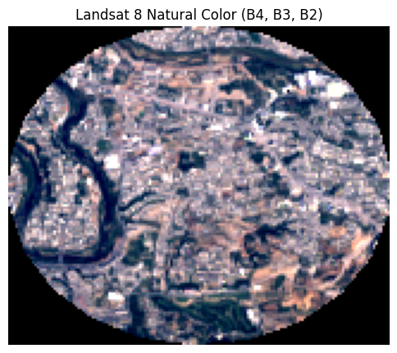
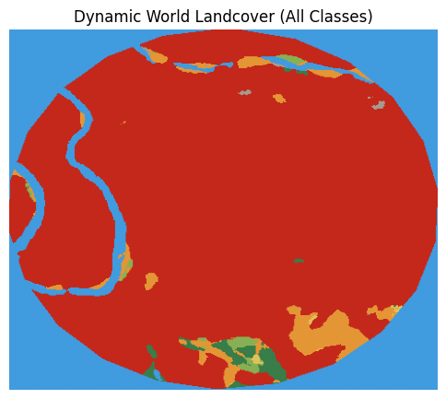

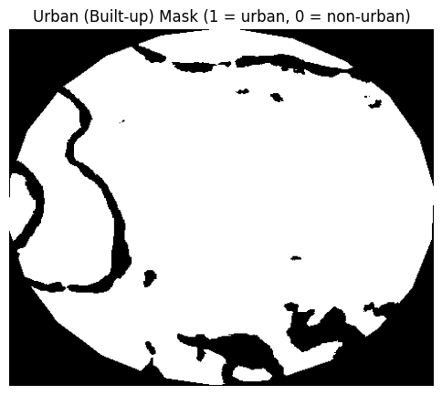

Landsat 8 Bands:
Band Number | Band Name | Wavelength (µm) | Spatial Resolution (m)
1 | Coastal /Aerosol | 0.43–0.45 | 30
2 | Blue | 0.45–0.51 | 30
3 | Green | 0.53–0.59 | 30
4 | Red | 0.64–0.67 | 30
5 | NIR | 0.85–0.88 | 30
6 | SWIR 1 | 1.57–1.65 | 30
7 | SWIR 2 | 2.11–2.29 | 30
8 | PAN (Panchromatic) | 0.50–0.68 | 15
9 | Cirrus | 1.36–1.38 | 30
10 | TIRS 1 (Thermal) | 10.6–11.19 | 100
11 | TIRS 2 (Thermal) | 11.50–12.51 | 100

Thermal Band Urban Settlement Indices:
- Normalized Difference Impervious Surface Index Using Visible Band (NDISI_VIS)
- Normalized Difference Impervious Surface Index Using Water Index (NDISI_WI )
- Enhanced Built-up and Bareness Index (EBBI)
- Modified Normalized Difference Impervious Surface Index (MNDISI)
- SwirTirRed (STRed) Index
- Normalized Difference Built Up Index OLI (NDBI_OLI)
- Built Up Area Extraction Method (BAEM)
- Normalized Difference Impervious Index (NDII)
- Dry Built Up Index (DBI)
The formulas of these are:
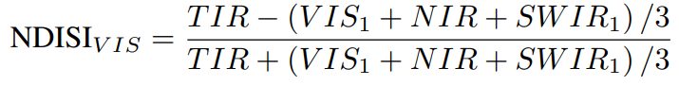
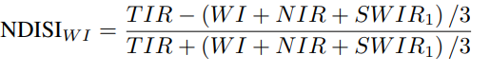
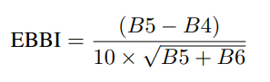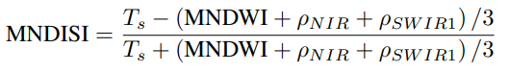
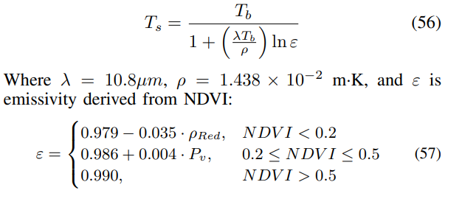
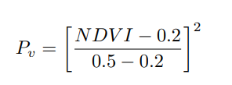

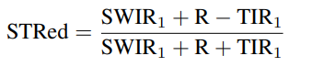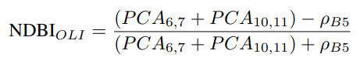
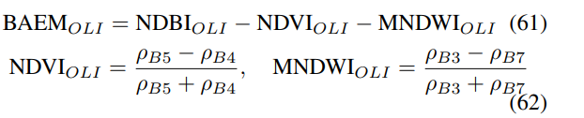
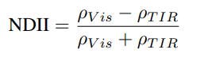
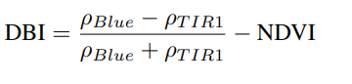
The code used for implementation is:
import rasterio
import numpy as np
import matplotlib.pyplot as plt
from matplotlib.colors import ListedColormap
from sklearn.metrics import (
jaccard_score, confusion_matrix, accuracy_score, precision_score,
recall_score, f1_score, balanced_accuracy_score, cohen_kappa_score,
roc_curve, auc
)
from skimage.transform import resize
import pandas as pd
import matplotlib.patches as mpatches
import os

# ======= Settings =======
landsat_path = r'C:\Users\Adeel Ajmal\Downloads\L8_BahriaPhase7_20231012.tif'
label_path = r'C:\Users\Adeel Ajmal\Downloads\DynamicWorld_LandcoverLabels.tif'
outdir = "urban_index_eval_thermal_all"
save_figs = True
os.makedirs(outdir, exist_ok=True)

# ======= 1. Load Data =======
with rasterio.open(landsat_path) as src:
stack = src.read().astype('float32')
b1,b2,b3,b4,b5,b6,b7,b8,b9,b10,b11 = stack

with rasterio.open(label_path) as src:
labels = src.read(1)

gt_mask = (labels == 6).astype(np.uint8)
gt_mask_resized = resize(
gt_mask,
(stack.shape[1], stack.shape[2]),
order=0, preserve_range=True, anti_aliasing=False
).astype(np.uint8)

# ======= 2. Define Indices (as per docx) =======
# Note: Add all requested indices here. All formulas are implemented below.
# For missing bands, formulas are adapted for Landsat 8. Each index is nan-masked if denominator can be zero.
def safe_div(num, denom):
out = np.full_like(num, np.nan)
valid = np.abs(denom) > 1e-6
out[valid] = num[valid] / denom[valid]
return out

indices = {}

# ---------- EXTRA PREP: Reflectance ratio bands (already float32) ----------
# Assumption: stack contains TOA reflectance for optical, TOA BT (Kelvin) for thermal.
rho_red = b4 # reflectance red
rho_nir = b5
rho_swir1= b6
rho_green= b3
rho_swir2= b7

# ---------- 1. NDVI, MNDWI (unchanged) ----------
NDVI = safe_div(rho_nir - rho_red, rho_nir + rho_red)
MNDWI = safe_div(rho_green - rho_swir1, rho_green + rho_swir1)

# ---------- 2. Emissivity ε (Sun et al., Eq. 57) ----------
Pv = ((NDVI - 0.2) / 0.3)**2
ε = np.where(
NDVI < 0.2,
0.979 - 0.035 * rho_red,
np.where(
NDVI <= 0.5,
0.986 + 0.004 * Pv,
0.990
)
)
ε = np.clip(ε, 0.85, 0.999) # keep within physical bounds

print("Band 10 min:", np.nanmin(b10), "max:", np.nanmax(b10))

# ---------- 3. Land-surface temperature Ts (Eq. 56) ----------
λ = 10.8e-6 # central wavelength (m) for L8 band 10
ρ_const = 1.438e-2 # m·K (Planck constant combo)
Tb = b10 # band 10 already in Kelvin
Ts = Tb / (1 + (λ * Tb / ρ_const) * np.log(ε))

# ---------- 4. TRUE PCA for bands (as expected in NDBI_OLI) ----------
from sklearn.decomposition import PCA

def first_pc(a, b):
h, w = a.shape
X = np.stack([a.ravel(), b.ravel()], axis=1)
pc1 = PCA(n_components=1).fit_transform(np.nan_to_num(X)).reshape(h, w)
return pc1.astype(np.float32)

PCA_6_7 = first_pc(rho_swir1, rho_swir2)
PCA_10_11 = first_pc(b10, b11)

# 1. NDISI_VIS (Xu 2010, Visible)
indices["NDISI_VIS"] = safe_div(3*b10 - b2 + b5 + b6, 3*b10 + b2 + b5 + b6 )

# 2. NDISI_WI (Xu 2010, Water Index, NDWI)
ndwi = safe_div(b3 - b5, b3 + b5)
indices["NDISI_NDWI"] = safe_div(3*b10 - ndwi + b5 + b6, 3*b10 + ndwi + b5 + b6 )

# 3. NDISI_MNDWI (Xu 2010, MNDWI)
mndwi = safe_div(b3 - b6, b3 + b6)
indices["NDISI_MNDWI"] = safe_div(3*b10 - mndwi + b5 + b6, 3*b10 + mndwi + b5 + b6 )

# 4. EBBI (As-syakur et al. 2012)
indices["EBBI"] = safe_div(b6 - b5, 10.0 * np.sqrt(b6 + b10) )

# 5. STRed (SwirTirRed)
indices["STRed"] = safe_div(b6 + b4 - b10, b6 + b10 + b4 )

# 8. NDII (Normalized Difference Impervious Index)
indices["NDII"] = safe_div(b4 - b10, b4 + b10 )

# 11. NDVI (for NDVI-thresholding, classic green-ness index)
ndvi = safe_div(b5 - b4, b5 + b4 )

# 9. DBI (Dry Built Up Index)
indices["DBI"] = safe_div(b2 - b10 - ndvi * (b2 + b10), b2 + b10 )

# ---------- 5. Re-compute target indices ----------
indices['MNDISI'] = safe_div(Ts - (MNDWI + rho_nir + rho_swir1) / 3,Ts + (MNDWI + rho_nir + rho_swir1) / 3)

indices['NDBI_OLI'] = safe_div((PCA_6_7 + PCA_10_11) - rho_nir,(PCA_6_7 + PCA_10_11) + rho_nir)

indices['BAEM'] = indices['NDBI_OLI'] - NDVI - MNDWI

# keep NDVI, MNDWI, etc. in dict if you still need them
indices['NDVI'] = NDVI
indices['MNDWI'] = MNDWI

# ======= 3. NDVI Threshold Search & Best Mask =======
ndvi_thresholds = np.arange(0.1, 0.81, 0.05)
best_results = {}
all_results = {}

def best_threshold(idx, truth, n_steps=200):
v = np.isfinite(idx) & np.isfinite(truth)
x, y = idx[v].ravel(), truth[v].ravel()
best_thr, best_iou = None, -1
for thr in np.linspace(np.nanmin(x), np.nanmax(x), n_steps):
y_pred = (x > thr).astype(np.uint8)
if y_pred.sum() == 0: continue
iou = jaccard_score(y, y_pred, zero_division=0)
if iou > best_iou: best_thr, best_iou = thr, iou
return best_thr

def metrics(mask_pred, truth, idx_pred_scores=None):
v = np.isfinite(mask_pred) & np.isfinite(truth)
y_pred, y_true = mask_pred[v].ravel(), truth[v].ravel()
out = dict(
IoU=jaccard_score(y_true, y_pred, zero_division=0),
F1=f1_score(y_true, y_pred, zero_division=0),
Pr=precision_score(y_true, y_pred, zero_division=0),
Re=recall_score(y_true, y_pred, zero_division=0),
Acc=accuracy_score(y_true, y_pred),
BAc=balanced_accuracy_score(y_true, y_pred),
Kappa=cohen_kappa_score(y_true, y_pred)
)
tn, fp, fn, tp = confusion_matrix(y_true, y_pred, labels=[0,1]).ravel()
out.update({"TP":tp,"TN":tn,"FP":fp,"FN":fn})
if idx_pred_scores is not None:
v2 = v & np.isfinite(idx_pred_scores)
y_true2 = truth[v2].ravel()
y_score2 = idx_pred_scores[v2].ravel()
if len(np.unique(y_true2)) > 1 and len(y_score2) > 0:
try:
fpr, tpr, _ = roc_curve(y_true2, y_score2)
out["AUC"] = auc(fpr, tpr)
except Exception as e:
out["AUC"] = np.nan
else:
out["AUC"] = np.nan
else:
out["AUC"] = np.nan
return out

for idx_name, idx in indices.items():
metric_by_thr = []
for ndvi_thr in ndvi_thresholds:
thr = best_threshold(idx, gt_mask_resized)
pred = ((idx > thr) & (ndvi < ndvi_thr)).astype(np.uint8)
result = metrics(pred, gt_mask_resized, idx_pred_scores=idx)
result['ndvi_thr'] = ndvi_thr
result['idx_thr'] = thr
metric_by_thr.append(result)
df_thr = pd.DataFrame(metric_by_thr)
best_i = df_thr['IoU'].idxmax()
best_results[idx_name] = df_thr.loc[best_i].to_dict()
all_results[idx_name] = df_thr

# ======= 4. Visualization: 3-panel for Each Index =======
class_palette = [
"#419bdf", "#397d49", "#88b053", "#7a87c6", "#e49635",
"#dfc35a", "#c4281b", "#a59b8f", "#ffffff"
]
class_names = [
"Water", "Trees", "Grass", "Flooded Veg", "Crops",
"Shrub/Scrub", "Built", "Bare", "Snow/Ice"
]
label_viz = resize(labels, (stack.shape[1], stack.shape[2]), order=0, preserve_range=True, anti_aliasing=False)

rgb = np.stack([b4, b3, b2], -1)
p2, p98 = np.nanpercentile(rgb, (2, 98))
rgb = np.clip((rgb - p2) / (p98 - p2), 0, 1)
rgb[np.isnan(rgb)] = 0

URBAN_COLOR = np.array([1.0, 0.1, 0.1])
NON_URBAN_COLOR = np.array([0.65, 0.65, 0.65])

for idx_name, idx in indices.items():
best = best_results[idx_name]
ndvi_thr = best['ndvi_thr']
idx_thr = best['idx_thr']
pred = ((idx > idx_thr) & (ndvi < ndvi_thr)).astype(np.uint8)

fig, axs = plt.subplots(1, 3, figsize=(22, 7))
axs[0].imshow(rgb)
axs[0].set_title("Landsat-8 RGB")
axs[0].axis('off')

im2 = axs[1].imshow(label_viz, cmap=ListedColormap(class_palette), vmin=0, vmax=8)
axs[1].set_title("Dynamic World Labels")
axs[1].axis('off')
cbar = plt.colorbar(im2, ax=axs[1], ticks=np.arange(0,9), shrink=0.8)
cbar.ax.set_yticklabels(class_names)

idx_disp = np.copy(idx)
idx_disp[~np.isfinite(idx_disp)] = np.nan
axs[2].imshow(idx_disp, cmap='RdYlBu')
gt_viz = np.zeros((*gt_mask_resized.shape, 3), dtype=np.float32)
gt_viz[gt_mask_resized == 1] = URBAN_COLOR
gt_viz[gt_mask_resized == 0] = NON_URBAN_COLOR
pred_viz = np.zeros((*pred.shape, 3), dtype=np.float32)
pred_viz[pred == 1] = URBAN_COLOR
pred_viz[pred == 0] = NON_URBAN_COLOR
axs[2].imshow(0.6*gt_viz + 0.4*pred_viz, alpha=0.45)
axs[2].set_title(f"{idx_name} Index\nIoU={best['IoU']:.3f} NDVI<{ndvi_thr:.2f}")
axs[2].axis('off')
handles = [
mpatches.Patch(color=URBAN_COLOR, label='Urban'),
mpatches.Patch(color=NON_URBAN_COLOR, label='Non-Urban')
]
axs[2].legend(handles=handles, loc='lower right', fontsize=12)
plt.tight_layout()
if save_figs:
plt.savefig(os.path.join(outdir, f"{idx_name}_urban3panel.png"), dpi=200, bbox_inches='tight')
plt.show()

# ======= 5. Save Summary Table =======
header = "{:<10} {:>8} {:>8} {:>8} {:>8} {:>8} {:>8} {:>8} {:>8} {:>6} {:>8}".format(
"Index","IoU","F1","Pr","Re","Acc","BAc","Kappa","AUC","TP","NDVI_thr")
print(header)
print("-"*len(header))
for k,v in best_results.items():
print("{:<10} {:8.3f} {:8.3f} {:8.3f} {:8.3f} {:8.3f} {:8.3f} {:8.3f} {:8.3f} {:6.0f} {:8.2f}".format(
k, v['IoU'], v['F1'], v['Pr'], v['Re'], v['Acc'], v['BAc'], v['Kappa'], v['AUC'], v['TP'], v['ndvi_thr']))
df = pd.DataFrame(best_results).T
df.to_csv(os.path.join(outdir, "urban_index_metrics_best.csv"))
for k, df_thr in all_results.items():
df_thr.to_csv(os.path.join(outdir, f"{k}_ndvi_threshold_sweep.csv"))
print("GT Urban Fraction: {:.2%}".format(gt_mask_resized.mean()))
vals, counts = np.unique(label_viz.astype(int), return_counts=True)
total = label_viz.size
print("\n--- Land Cover Breakdown (Dynamic World) ---")
for v, c in zip(vals, counts):
print(f"{class_names[v]:<12}: {c/total*100:5.2f}%")

import numpy as np
import matplotlib.pyplot as plt
from sklearn.metrics import confusion_matrix
import seaborn as sns
import os

def plot_confusion_matrix(y_true, y_pred, idx_name, outdir, labels=['Non-Urban', 'Urban']):
cm = confusion_matrix(y_true, y_pred, labels=[0,1])
plt.figure(figsize=(4,4))
sns.heatmap(cm, annot=True, fmt='d', cmap='Blues',
xticklabels=labels, yticklabels=labels,
cbar=False)
plt.xlabel('Predicted Label')
plt.ylabel('True Label')
plt.title(f'{idx_name} - Confusion Matrix')
plt.tight_layout()
# Save the figure
plt.savefig(os.path.join(outdir, f"{idx_name}_confusion_matrix.png"), dpi=150)
plt.close()

# Main loop: Go through all indices
for idx_name, idx in indices.items():
best = best_results[idx_name]
ndvi_thr = best['ndvi_thr']
idx_thr = best['idx_thr']
pred = ((idx > idx_thr) & (NDVI < ndvi_thr)).astype(np.uint8)
y_true = gt_mask_resized.ravel()
y_pred = pred.ravel()
plot_confusion_matrix(y_true, y_pred, idx_name, outdir)

print(f"Confusion matrix PNGs saved to {outdir}")

Output:
NDISI_VIS Result:
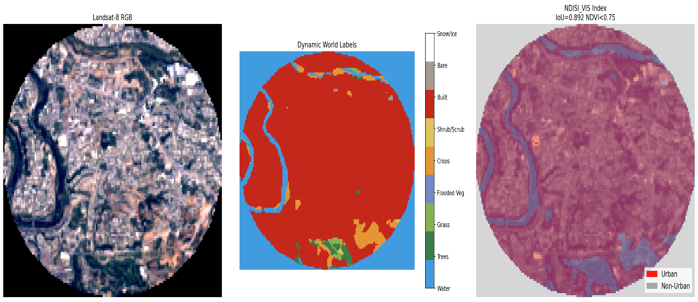
NDISI_NDWI Result:
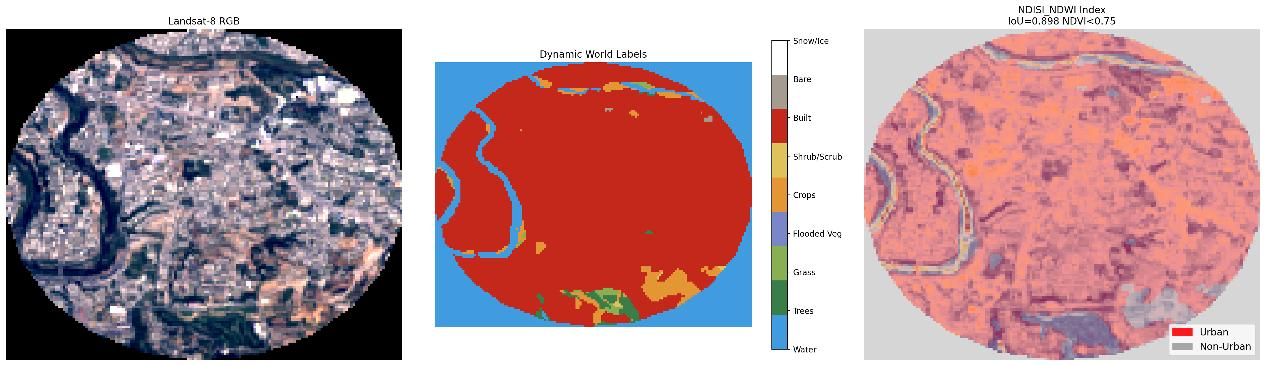
NDISI_MNDWI Result:
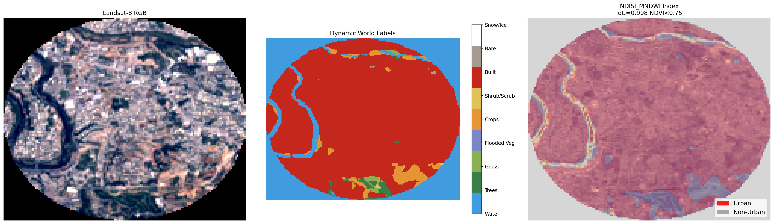

EBBI Result:
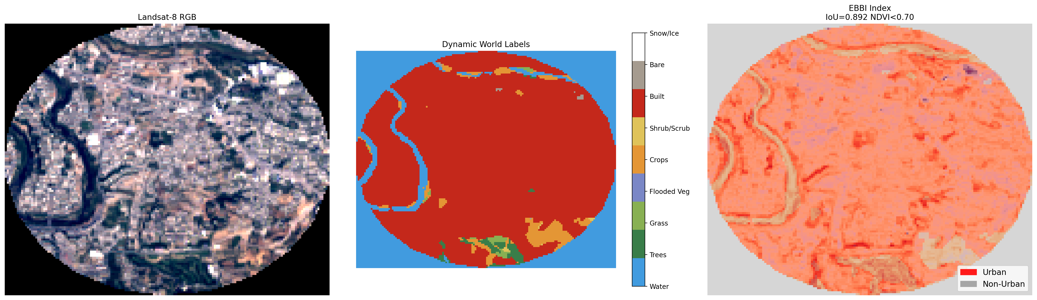
STRED Result:
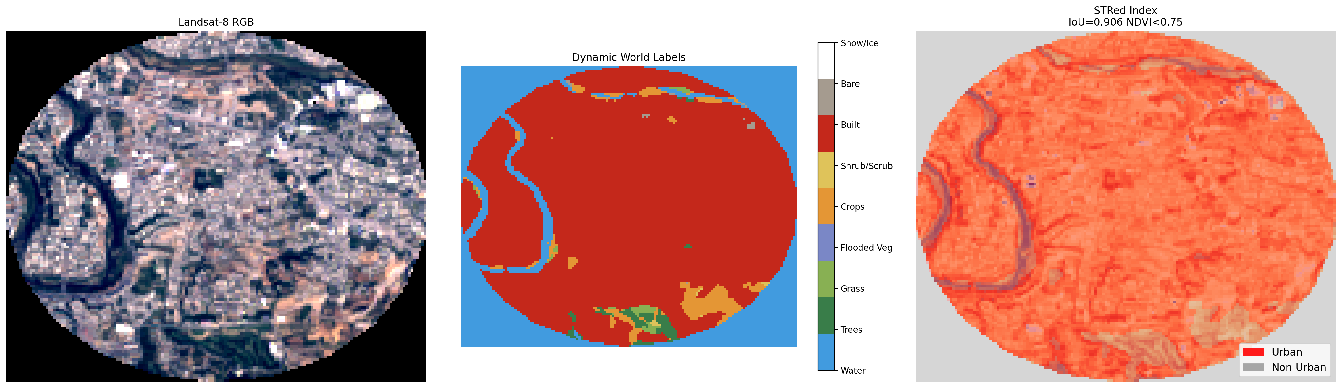

NDII Result:
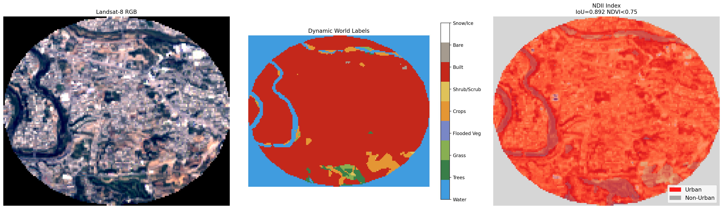
DBI Result:
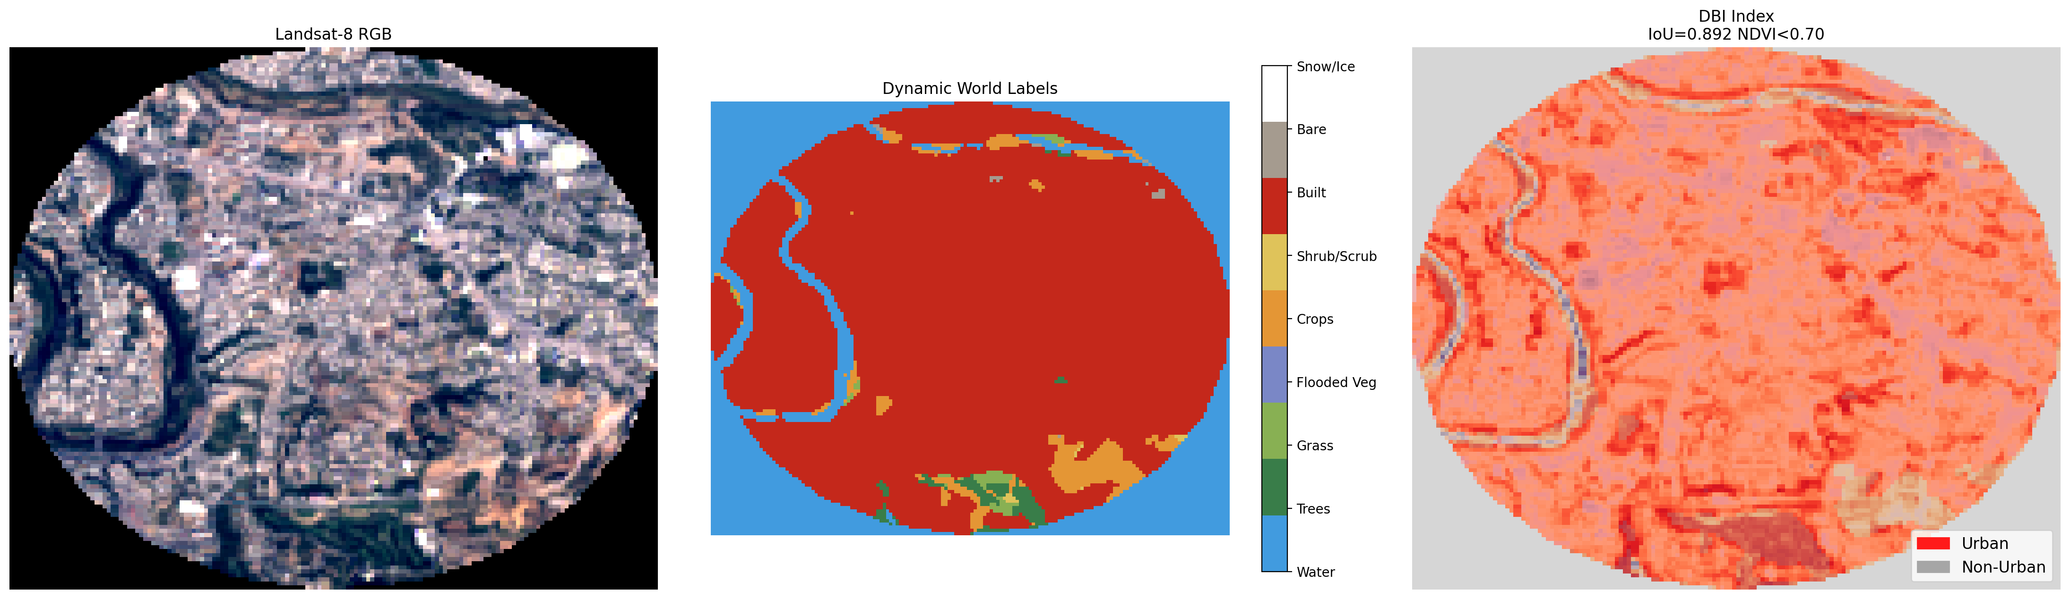
MNDISI Result:
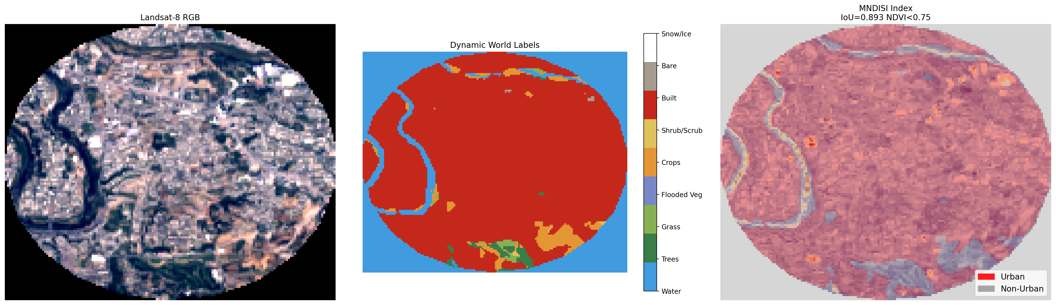
NDBI_OLI Result:
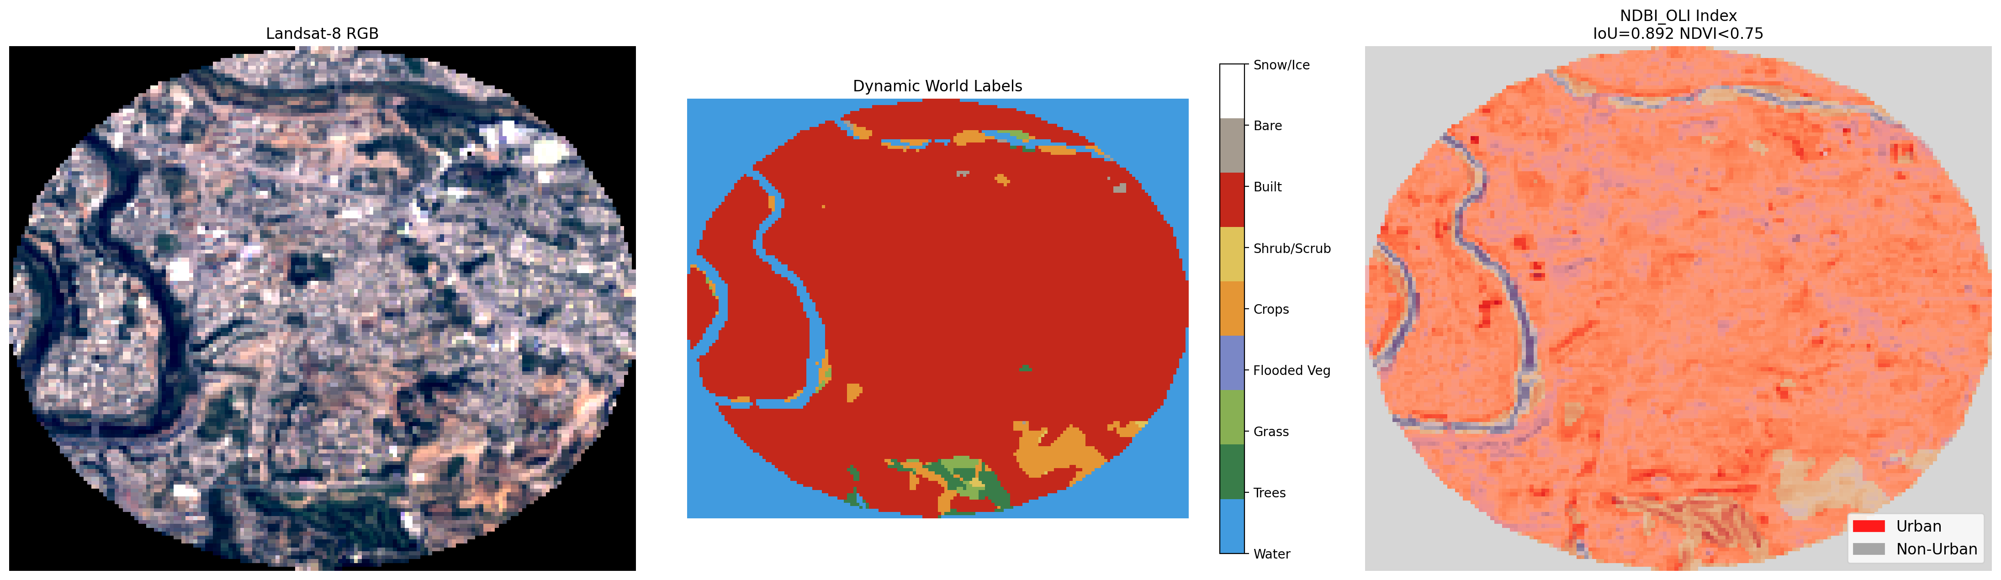
BAEM Result:
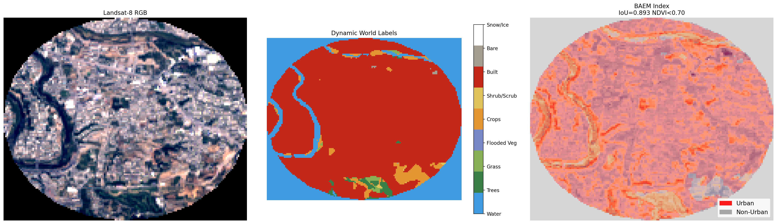

Metrics Result For Each Index:
Index Name | IoU-score | F1-score | Precision | Recall | Accuracy | Balanced Accuracy Score | Kappa Score
NDISI_VIS | 0.891833 | 0.942824 | 0.892891 | 0.998673 | 0.914879 | 0.857723 | 0.778343
NDISI_NDWI | 0.898213 | 0.946377 | 0.900312 | 0.997412 | 0.920569 | 0.868155 | 0.794778
NDISI_MNDWI | 0.907902 | 0.951728 | 0.911933 | 0.995155 | 0.929058 | 0.883973 | 0.818922
EBBI | 0.891833 | 0.942824 | 0.892891 | 0.998673 | 0.914879 | 0.857723 | 0.778343
STRED | 0.906447 | 0.950928 | 0.912362 | 0.992898 | 0.927985 | 0.883708 | 0.816583
NDII | 0.892412 | 0.943148 | 0.894377 | 0.997544 | 0.915485 | 0.859513 | 0.78043
DBI | 0.891833 | 0.942824 | 0.892891 | 0.998673 | 0.914879 | 0.857723 | 0.778343
MNDISI | 0.892827 | 0.94338 | 0.898457 | 0.993031 | 0.916231 | 0.863846 | 0.783983
NDBI_OLI | 0.891773 | 0.942791 | 0.892885 | 0.998606 | 0.914832 | 0.85769 | 0.778233
BAEM | 0.893379 | 0.943688 | 0.895241 | 0.997677 | 0.916325 | 0.860834 | 0.782761

Index Name | True Positives | True Negatives | False Positives | False Negatives | Area Under the Curve | NDVI threshold
NDISI_VIS | 15047 | 4568 | 1805 | 20 | 0.13858 | 0.75
NDISI_NDWI | 15028 | 4709 | 1664 | 39 | 0.368948 | 0.75
NDISI_MNDWI | 14994 | 4925 | 1448 | 73 | 0.440867 | 0.75
EBBI | 15047 | 4568 | 1805 | 20 | 0.719775 | 0.7
STRED | 14960 | 4936 | 1437 | 107 | 0.761806 | 0.75
NDII | 15030 | 4598 | 1775 | 37 | 0.7981 | 0.75
DBI | 15047 | 4568 | 1805 | 20 | 0.640227 | 0.7
MNDISI | 14962 | 4682 | 1691 | 105 | 0.404183 | 0.75
NDBI_OLI | 15046 | 4568 | 1805 | 21 | 0.505562 | 0.75
BAEM | 15032 | 4614 | 1759 | 35 | 0.757748 | 0.7

Confusion Matrix of Indices:
